TEST5

Question 1

In a system designed to work out the tax to be paid:

An employee has £4000 of salary tax free.

The next £1500 is taxed at 10%.

The next £28000 after that is taxed at 22%.

Any further amount is taxed at 40%.

To the nearest whole pound, which of these groups of numbers fall into three DIFFERENT equivalence classes?

A £4000; £5000; £5500.

B £32001; £34000; £36500.

C £28000; £28001; £32001.

D £4000; £4200; £5600.

-----------------------------------------------------------------------------------------------------------

Question 2

Given the following specification, which of the following values for age are in the SAME equivalence partition?

If you are less than 18, you are too young to be insured.

Between 18 and 30 inclusive, you will receive a 20% discount.

Anyone over 30 is not eligible for a discount.

A 17, 18, 19.

B 29, 30, 31.

C 18, 29, 30.

D 17, 29, 31.

-----------------------------------------------------------------------------------------------------------

Question 3

Consider the following techniques. Which are static and which are dynamic techniques?

1. Equivalence Partitioning.
2. Use Case Testing.
3. Data Flow Analysis.
4. Exploratory Testing.
5. Decision Testing.
6. Inspections.

A i-iv are static, v-vi are dynamic.

B iii and vi are static, i, ii, iv and v are dynamic.

C ii, iii and vi are static, i, iv and v are dynamic.

D vi is static, i-v are dynamic.

-----------------------------------------------------------------------------------------------------------

Question 4

One of the fields on a form contains a text box which accepts numeric values in the range of 18 to 25. Indentify the invalid Equivalence class

A 17

B 19

C 24

D 21

-----------------------------------------------------------------------------------------------------------

Question 5

What is the expected result for each of the following test cases?

**Rule 1 Rule 2 Rule 3 Rule 4**

**Conditions:**

Indian resident? False True True True

Age between 18 – 55? Don’t care False True True

Married? Don’t care Don’t care False True

**Actions:**

Issue Memebership? False False True True

Offer 10% discount? False False True False

A.TC1: Anand is a 32 year old married, residing in Kolkatta.

B.TC3: Attapattu is a 65 year old married person, residing in Colombo.

A A – Issue membership, 10% discount, B – Issue membership, offer no discount.

B A – Don’t Issue membership, B – Don’t offer discount.

C A – Issue membership, no discount, B – Don’t Issue membership.

D A - Issue membership, no discount, B- Issue membership with 10% discount.

**Remember the terms from the lesson:**

***static testing, dynamic testing, equivalence partitioning, boundary value analysis, decision table testing, state transition testing, use case testing***

**Write test cases for the following system, described as a graph:**

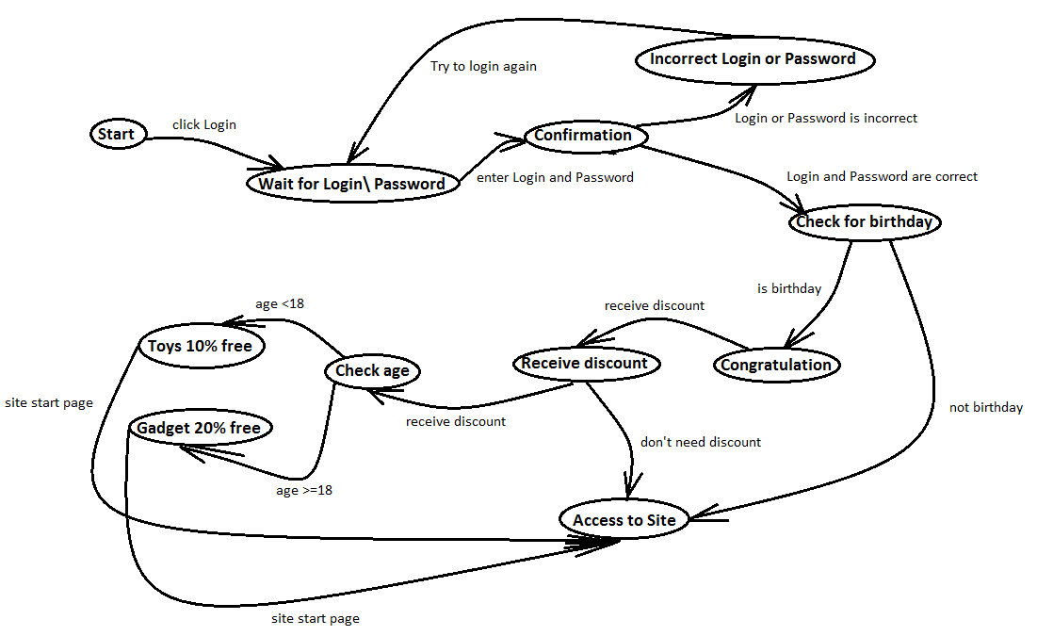

Use all knowledge received on the lesson.